11.48: From the figure (and from common sense), the force 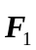 is directed along the length of the nail, and so has a moment arm of (0.0800 m) 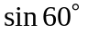. The moment arm of 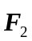 is 0.300 m, so

